DEPLOYING A MICROSERVICES ARCHITECTURE APPLICATION USING KUBERNETES, GITHUB ACTIONS, ARGO CD, PROMETHEUS AND GRAFANA

Project Report
Department: Computer Science and Engineering
Year: III Year
Institution: Nehru Institute of Technology

ABSTRACT
Microservices architecture has become the preferred approach for developing scalable and maintainable cloud-native applications. Unlike monolithic applications, microservices divide an application into multiple independent services that communicate through APIs. This enables independent deployment, scalability, fault isolation, and easier maintenance.
This project demonstrates the deployment of Google's Online Boutique microservices application on Kubernetes running on an AWS EC2 instance using K3s. Helm is used to deploy the application, while Kubernetes manages the containerized services. The frontend service is exposed externally using a NodePort, allowing users to access the application through a web browser.
The project also introduces modern DevOps tools such as GitHub Actions for Continuous Integration (CI), Argo CD for GitOps-based Continuous Deployment (CD), Prometheus for monitoring, and Grafana for visualization. Although these tools are discussed conceptually, the practical implementation focuses on successfully deploying and accessing the Kubernetes application.

TABLE OF CONTENTS
- Introduction
- Objectives
- System Architecture
- Tools and Technologies
- Project Implementation
- GitHub Actions
- Argo CD
- Prometheus
- Grafana
- Results
- Advantages
- Future Scope
- Conclusion
1. INTRODUCTION
Cloud-native applications are designed to run efficiently on container orchestration platforms such as Kubernetes. Instead of packaging all functionality into a single application, microservices divide an application into smaller independent services.
Each microservice performs a specific business function and communicates with other services over the network. Kubernetes automates deployment, scaling, networking, and recovery of these services.
The Online Boutique application developed by Google demonstrates a complete cloud-native e-commerce platform consisting of multiple interconnected microservices.

2. OBJECTIVES
The objectives of this project are:
- Deploy a cloud-native microservices application.
- Learn Kubernetes fundamentals.
- Deploy applications using Helm.
- Configure Kubernetes Services.
- Expose applications externally using NodePort.
- Understand CI/CD concepts.
- Learn GitOps deployment using Argo CD.
- Monitor Kubernetes using Prometheus.
- Visualize metrics using Grafana.

3. SYSTEM ARCHITECTURE
Developer
│
▼
GitHub Repository
│
▼
GitHub Actions
(Build Docker Images)
│
▼
Docker Hub
│
▼
Argo CD
│
▼
Kubernetes Cluster
│
▼
Online Boutique Microservices
│
▼
Prometheus
│
▼
Grafana Dashboard

4. TOOLS AND TECHNOLOGIES
Tool | Purpose
AWS EC2 | Virtual Machine
Ubuntu 22.04 | Operating System
Docker | Container Runtime
Kubernetes (K3s) | Container Orchestration
kubectl | Kubernetes CLI
Helm | Package Manager
GitHub | Source Code Management
GitHub Actions | Continuous Integration
Argo CD | Continuous Deployment
Prometheus | Monitoring
Grafana | Visualization

5. PROJECT IMPLEMENTATION
Step 1: Launch AWS EC2 Instance
An Ubuntu EC2 instance was created on AWS to host the Kubernetes cluster. The instance serves as the control plane where all Kubernetes components and application services run.

Step 2: Configure Security Groups
The EC2 Security Group was configured to allow the necessary inbound traffic.
Allowed Ports:
- SSH (22)
- HTTP (80)
- HTTPS (443)
- NodePort (32368)
- NodePort (32655)
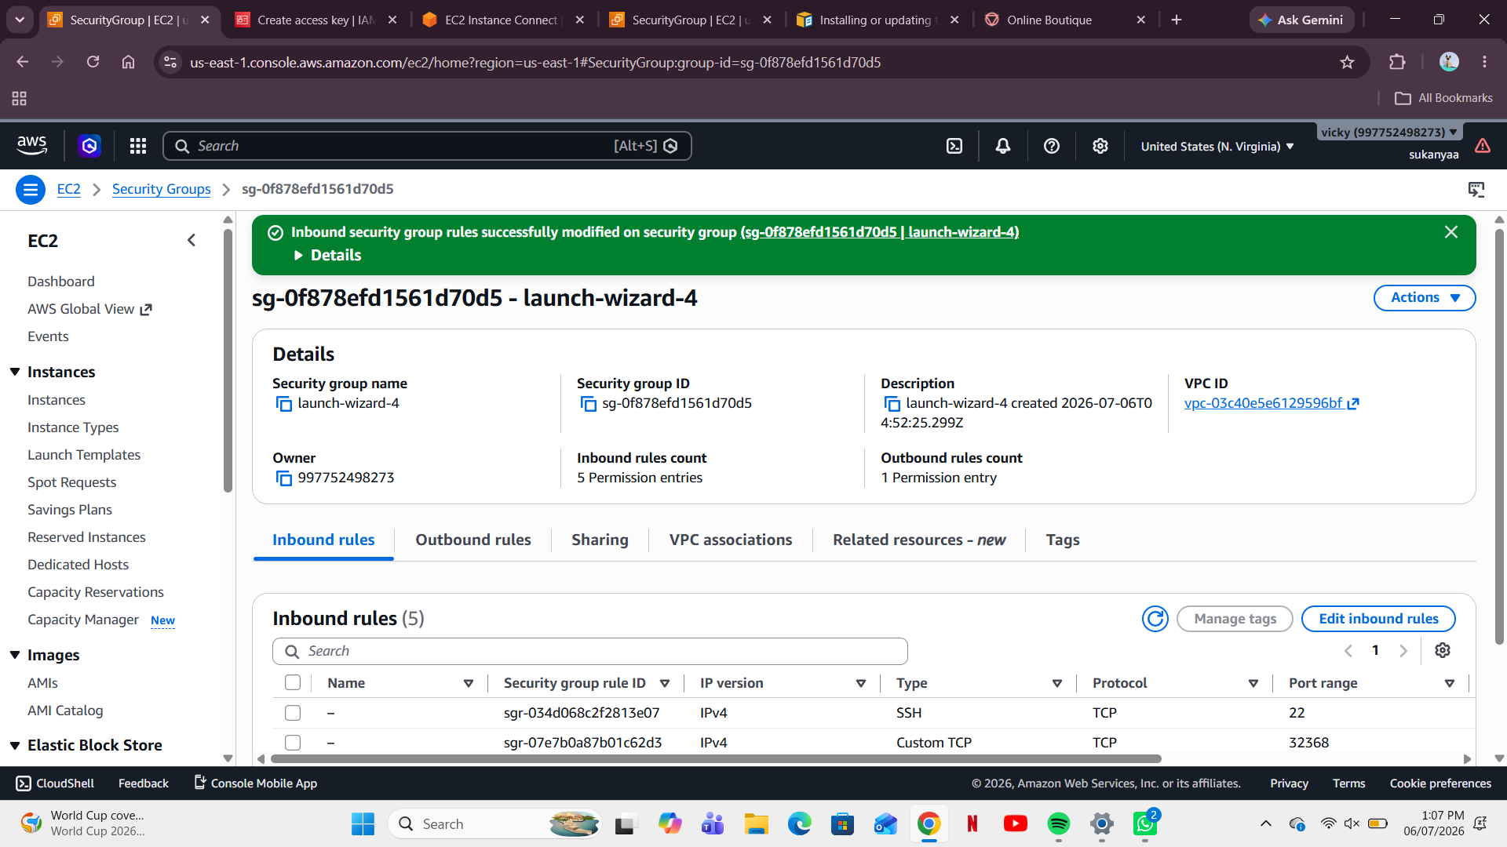
AWS EC2 Security Group Configuration

Step 3: Create IAM Access Keys
An IAM user was created, and an Access Key along with a Secret Access Key was generated. These credentials enable authenticated AWS CLI access for deployment and management tasks.
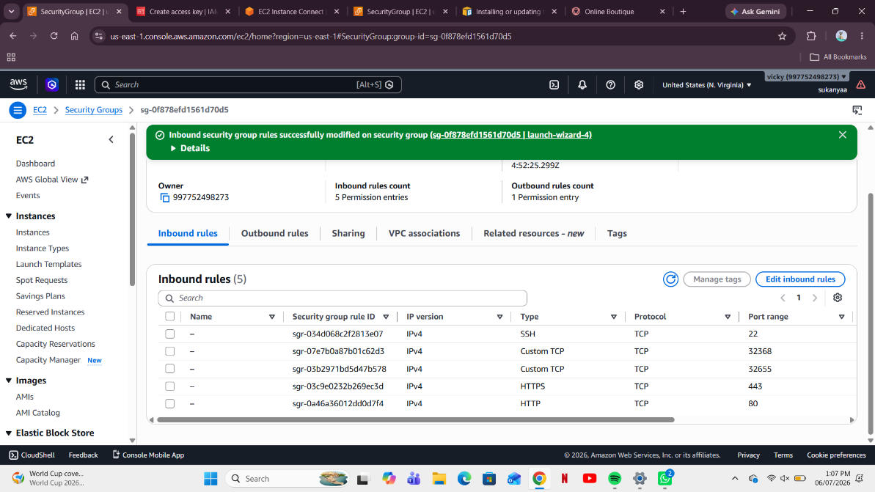
IAM Access Key Creation
Step 4: Install Kubernetes and Helm
The following components were installed on the EC2 instance:
- Docker
- Kubernetes (K3s)
- kubectl
- Helm
Helm installation was verified using:
helm version

Step 5: Deploy the Online Boutique Application
The Online Boutique microservices application was deployed using Helm.
helm install boutique . -n boutique
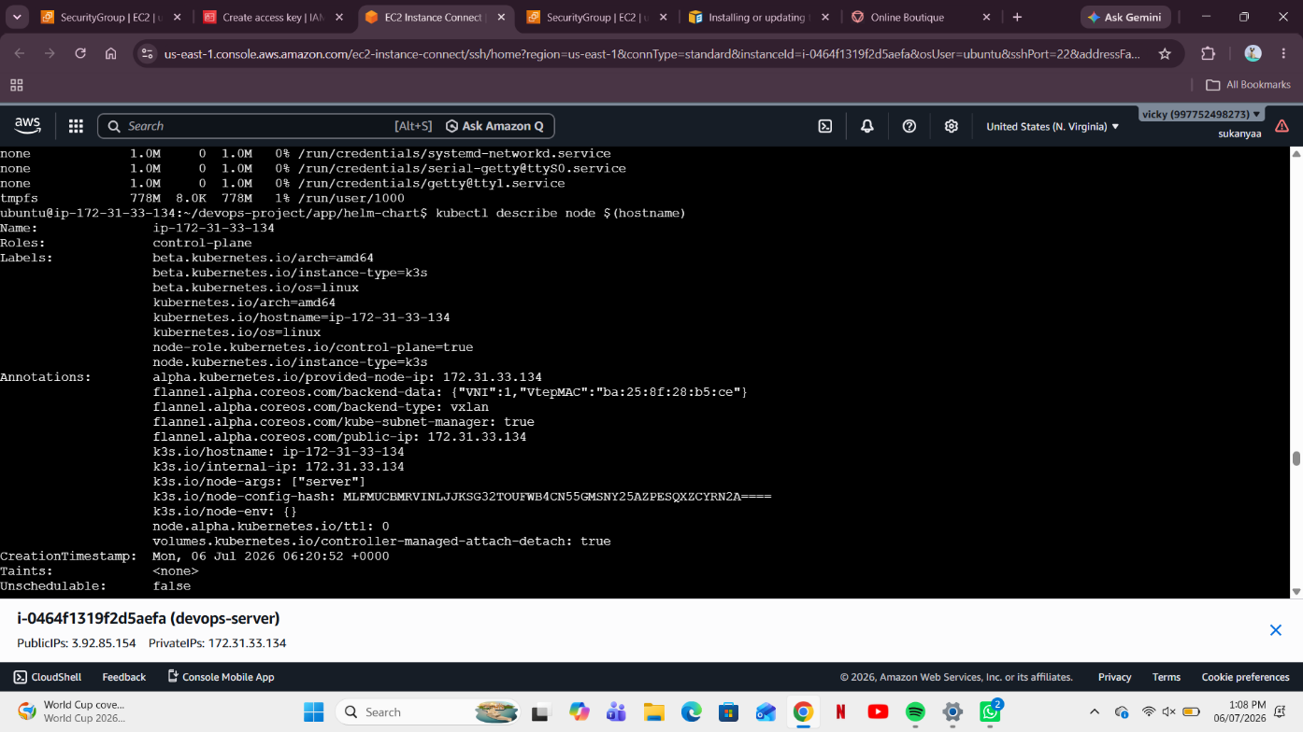
This command created all Kubernetes Deployments, Services, and Pods required by the application.

Helm Deployment of Online Boutique
Step 6: Verify Kubernetes Cluster
The Kubernetes node status was verified.
kubectl get nodes
The detailed node information was also inspected.
kubectl describe node
The node was in the Ready state, confirming successful Kubernetes installation.
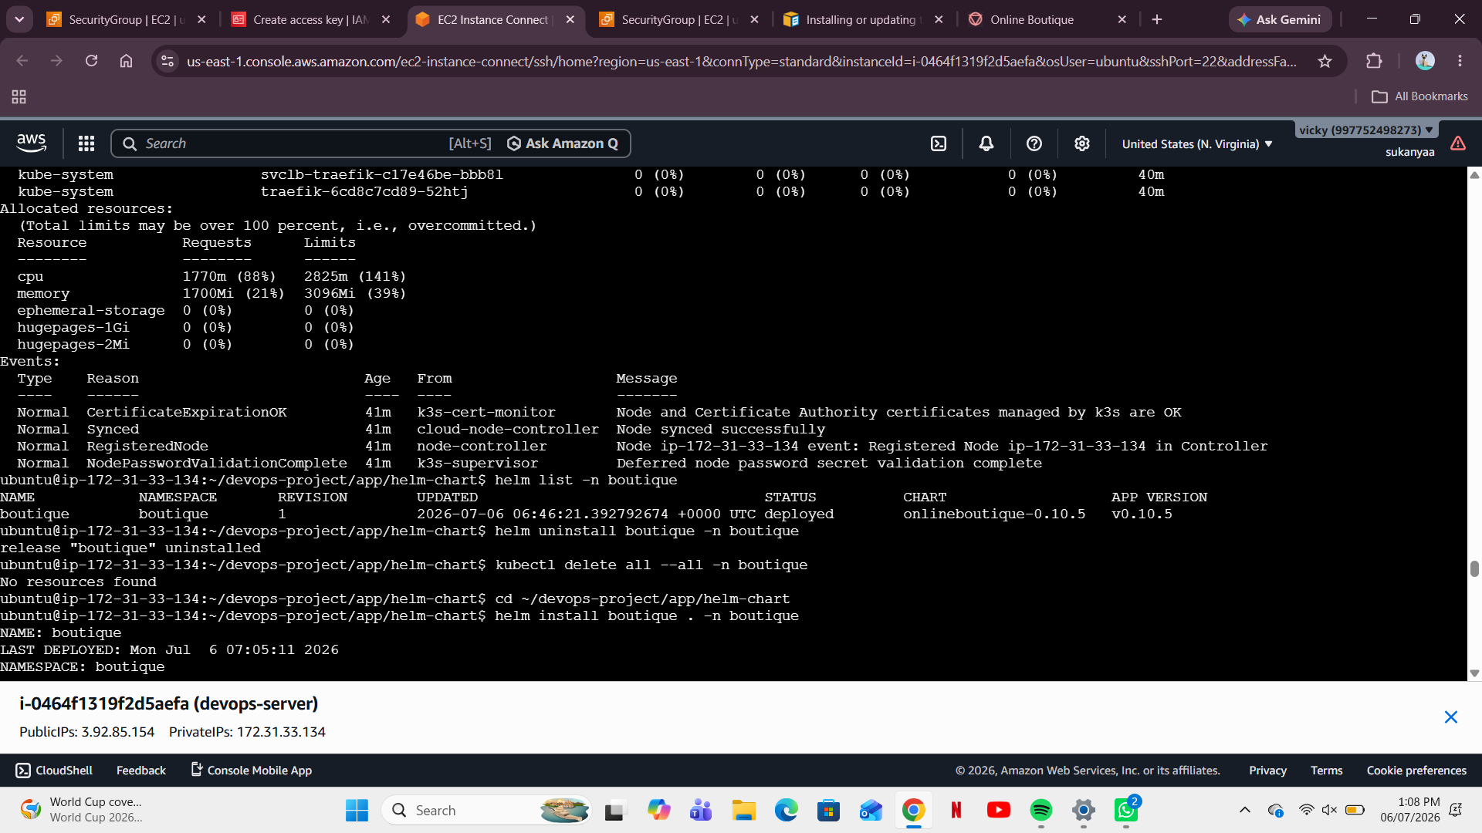
Kubernetes Node Description

Step 7: Verify Kubernetes Services
The deployed services were listed.
kubectl get svc -n boutique
The following services were observed:
- frontend
- cartservice
- checkoutservice
- paymentservice
- recommendationservice
- productcatalogservice
- shippingservice
- currencyservice
- emailservice
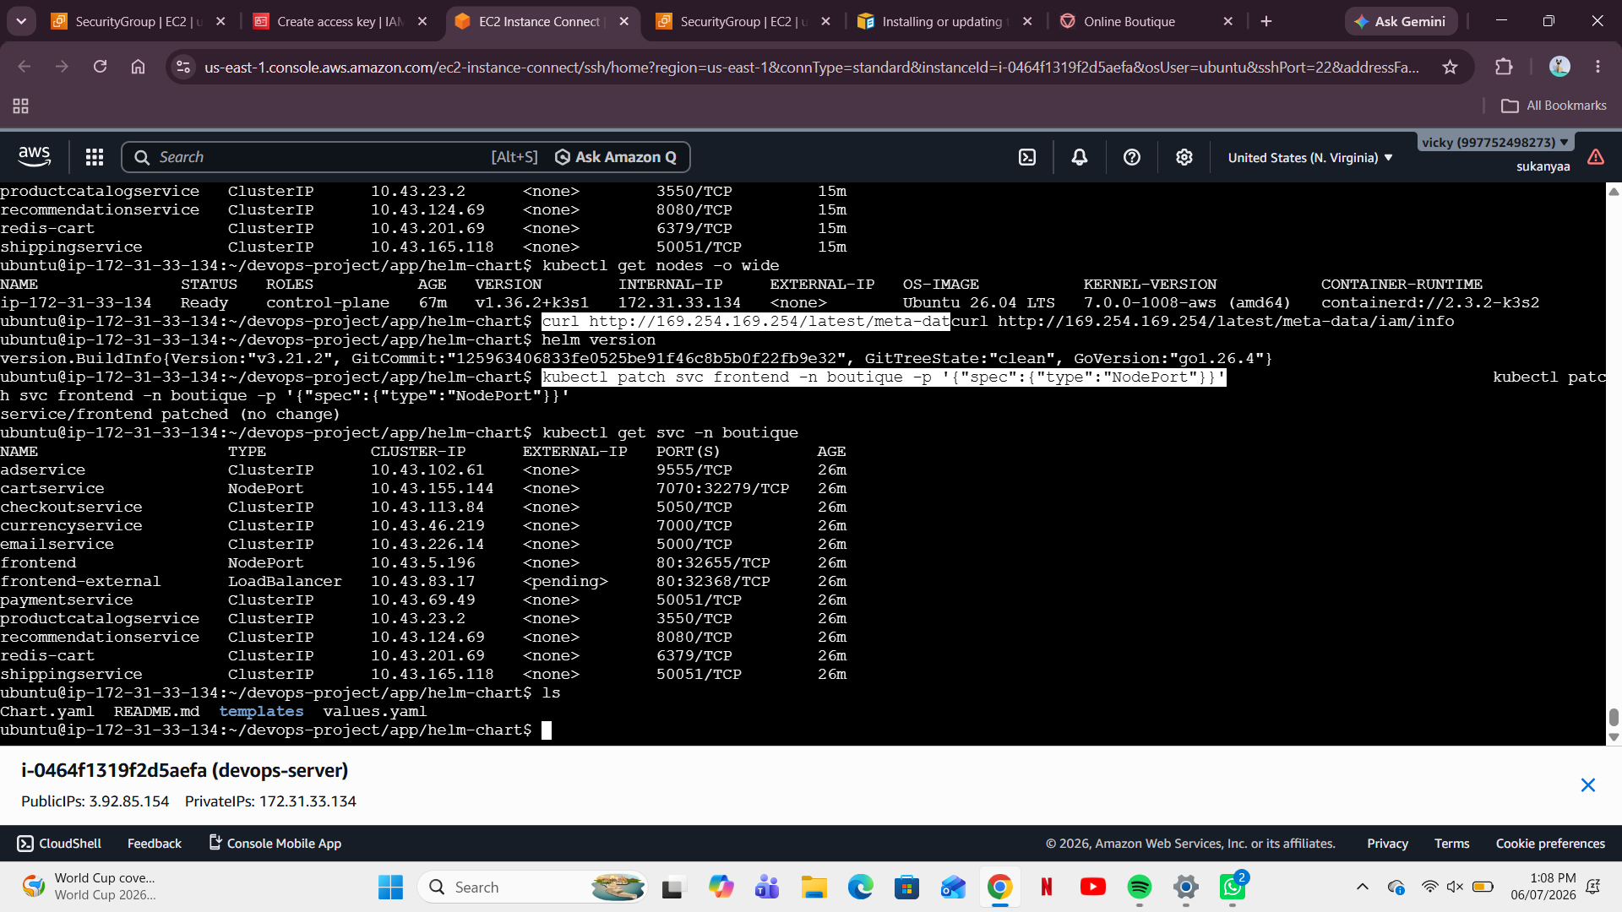
Kubernetes Services

Step 8: Expose Frontend Using NodePort
To allow external access, the frontend service was converted into a NodePort.
kubectl patch svc frontend -n boutique -p '{"spec":{"type":"NodePort"}}'
The assigned NodePort was 32655.
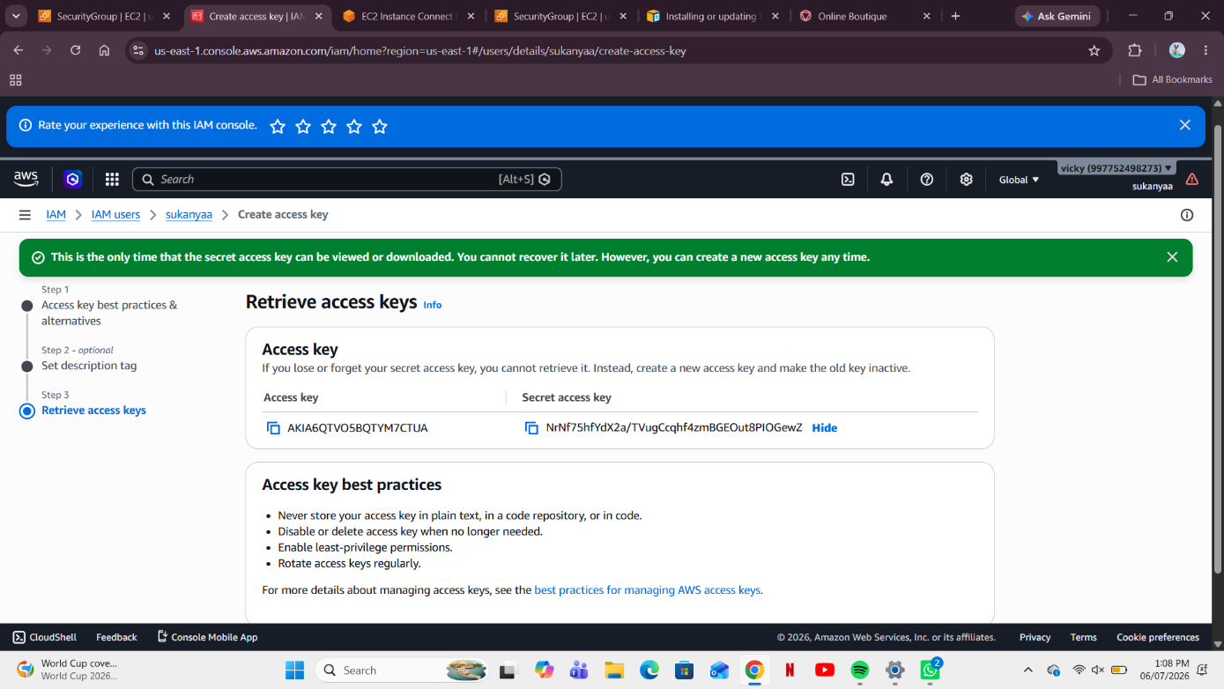
Frontend Service Exposed Using NodePort

Step 9: Access the Application
The application was accessed through the browser using:
http://Public-IP:32655
The homepage loaded successfully and displayed all products.
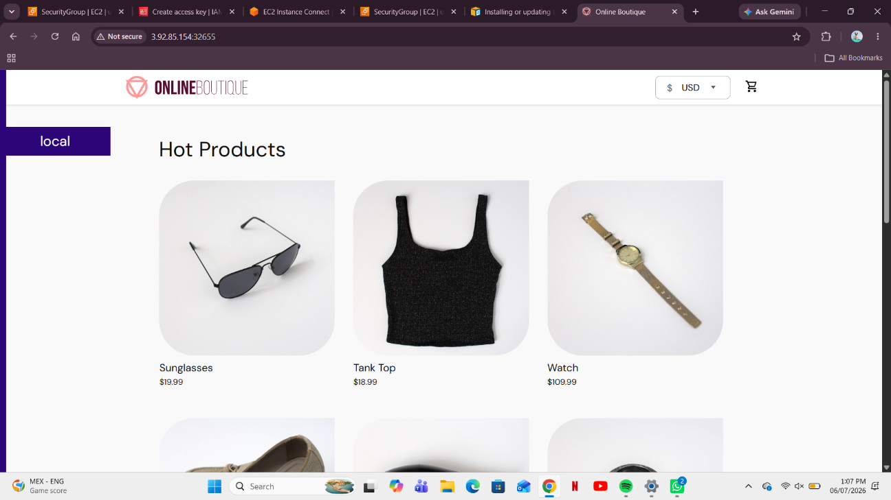
Online Boutique Home Page
Step 10: Verify Checkout Process
Products were added to the shopping cart, and the checkout page was successfully displayed.
The checkout page showed:
- Product information
- Shipping details
- Payment details
- Order summary
- Total amount
This confirmed successful communication among all backend microservices.
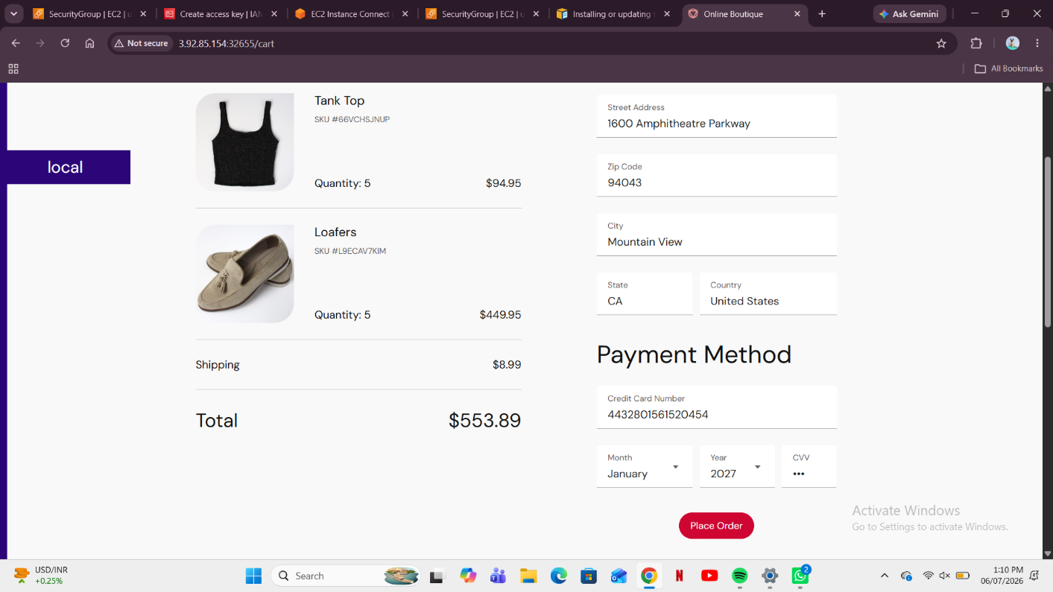
Checkout Page

6. GITHUB ACTIONS
GitHub Actions automates the Continuous Integration (CI) process.
Typical workflow:
- Developer pushes code to GitHub.
- GitHub Actions starts automatically.
- Docker image is built.
- Image is pushed to Docker Hub.
- Deployment manifests are updated.
Example workflow:
name: CI Pipeline

on:
push:
branches:
- main

jobs:
build:
runs-on: ubuntu-latest

steps:
- uses: actions/checkout@v3

- name: Build Docker Image
run: docker build -t username/app .

- name: Push Image
run: docker push username/app

7. ARGO CD
Argo CD provides GitOps-based Continuous Deployment.
Functions include:
- Watches GitHub repository
- Detects manifest changes
- Synchronizes Kubernetes cluster automatically
- Supports rollback
- Maintains desired state
Deployment commands:
kubectl create namespace argocd

kubectl apply -n argocd \
-f install.yaml

8. PROMETHEUS
Prometheus continuously collects Kubernetes metrics.
Collected metrics include:
- CPU utilization
- Memory utilization
- Pod status
- Node health
- Network traffic
Benefits:
- Real-time monitoring
- Performance analysis
- Alert generation
9. GRAFANA
Grafana visualizes Prometheus metrics.
Dashboards display:
- CPU usage
- Memory usage
- Node performance
- Pod performance
- Cluster health
Grafana enables administrators to quickly identify bottlenecks and monitor application health.

10. RESULTS
The project successfully achieved the following:
- AWS EC2 instance created.
- Security Groups configured.
- IAM credentials generated.
- Kubernetes (K3s) installed.
- Helm installed successfully.
- Online Boutique deployed.
- Kubernetes services verified.
- Frontend exposed through NodePort.
- Application accessed through public IP.
- Checkout functionality tested successfully.

11. ADVANTAGES
- High scalability
- Independent deployment of services
- Better fault isolation
- Easier maintenance
- Automated deployments
- Easy monitoring
- Improved reliability
- Cloud-native architecture

12. FUTURE SCOPE
Future improvements include:
- Deploy on Amazon EKS instead of K3s.
- Configure GitHub Actions for automated Docker image builds.
- Integrate Argo CD for automatic GitOps deployments.
- Install Prometheus and Grafana for production monitoring.
- Use Ingress Controller with Load Balancer instead of NodePort.
- Implement Horizontal Pod Autoscaling (HPA).
- Add CI/CD security scanning.

13. CONCLUSION
This project successfully demonstrated the deployment of a cloud-native microservices application using Kubernetes and Helm on an AWS EC2 instance. The Online Boutique application was deployed as multiple interconnected microservices, and the frontend was successfully exposed using a NodePort, allowing external access through a web browser. Functional testing confirmed that users could browse products, add items to the cart, and complete the checkout workflow, validating communication among all backend services.
The project also explored modern DevOps practices by discussing the roles of GitHub Actions for Continuous Integration, Argo CD for GitOps-based Continuous Deployment, Prometheus for monitoring, and Grafana for visualization. Although the practical implementation used a single-node K3s cluster, the deployment process closely resembles an Amazon EKS environment and provides a strong foundation for migrating to a managed Kubernetes service in future work. Overall, the project enhanced understanding of Kubernetes, microservices, Helm, and cloud-native application deployment while demonstrating industry-standard DevOps workflows.

